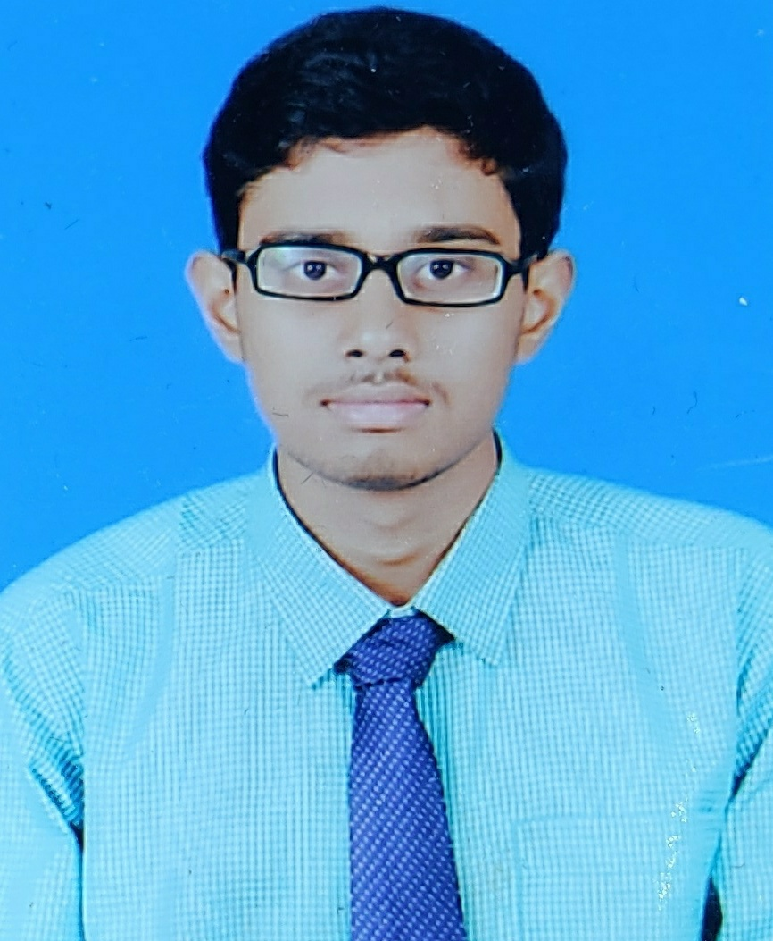
RESUME

KARTHIKEYAN.S
Dno:HIG-13, TNHB Colony,
Bagalur road,
Hosur,
Tamilnadu,
India. Email : karthikselvaraju007@gmail.com
Mob no:8072307090

OBJECTIVE:
To work in a challenging environment where I can enhance my skill and deliver my best effort with the utilization of my knowledge for the growth of the organization, and to obtain a challenging and professional position as an Electrical Engineer.

TECHNICAL SKILLS:

- Operating System : Windows,linux .
- Programming Languages : C, JAVA,C++
- Office Suite : Microsoft Office (Word/Excel/PowerPoint)
- Software : MATLAB

EDUCATIONAL QUALIFICATION:

Course | Board/university | % of Marks &  Year of Passing | Institution
B.E(EEE) | Anna University,Chennai | 7.3 CGPA (2017-21) | St.Joesph’s College of Engineering,Chennai
H.S.C | Tamil Nadu State Board | 90.5%  March 2017 | Sri vijay vidyalaya mat.hr.sec.school,Hosur
S.S.L.C | Matriculation | 95.2%  March 2015 | Sri vijay vidyalaya mat.hr.sec.school,Hosur

AREA’s OF INTEREST:
- Internet Of Things
- Embedded Systems
PROJECTS :
- A mini project on “RAILWAY TRACK CRACK DETECTION SYSTEM”, where the cracks are sensed and notification is sent through a GSM module.
- A project on “ WELCOME ROBOT” ,it senses the persons with help of motion sensor
PERSONAL TRAITS:
- Goal Oriented
- Dynamic & Hardworking
- Good in Team Work
- Good in Inter personal relationship and communications
CO-CURRICULAR ACTIVITIES:
- I have undergone implant training in AVTEC Ltd,Hosur
- I have undergone an internship program on “POWER MANAGEMENT” in YEKO enterprises

PERSONAL DETAILS:

Date of Birth : 20/10/1999
Father Name : Selvaraju.k
Sex : Male
Marital Status : Single
Language Known : English ,Tamil.
Hobbies : reading books,playing shuttle
Contact No : 80723-07090

DECLARATION

I declare that the information and facts stated above are true and correct to the best of my knowledge and belief.

Date : 31.12.2020 KARTHIKEYAN.S
Place : HOSUR

